**COMSATS University, Islamabad**

Assignment # 1

Virtual Reality / Augmented Reality Applications

Author: Muhammad Mujtaba

SP22-BSE-036

Course: ICT (CSC-101)

Instructor: Mam Hufsa Mohsin

Date: March 10, 2022

Introduction

AR stands for Augmented Reality and VR stands for Virtual Reality. Both technologies are used to bridge the digital and physical world. This is done through the use of enhanced 3D visuals by these technologies. Although both technologies are similar, but there is some distinction between the two, addressed below.

1. AR

AR morphs the physical world into a colorful visual world by projecting virtual pictures and characters through a phone's camera or video viewer. Augmented reality is merely adding to the user's real-life experience.

1. VR

VR uses same components but produces entirely computer-generated simulation of the alternative world. These immersive simulations can create almost any visual or place imaginable for the player using special equipment such as computers, sensors, headsets, and gloves.

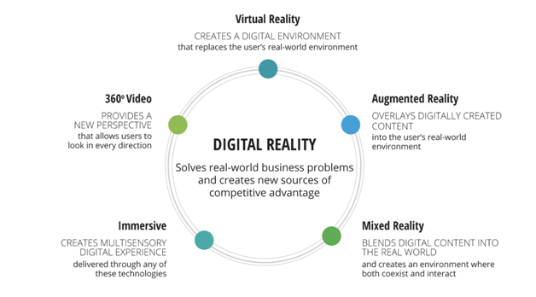

Figure 1: The brief summarization of all digital reality technologies. AR and VR are just two of their types

AR/VR Apps

AR/VR softwares include the following that are being used in different domains:

1. Microsoft HoloLens
2. Google ARCore
3. ARKit
4. Holokit
5. Google Expeditions
6. Google Lens

We choose **Google Expeditions** for further discussion.

Google Expeditions

Google Expeditions is a virtual reality (VR) platform developed by Google and designed for educational institutions. Using Android or iOS smartphones, the companion mobile app and head-mounted displays such as Google Cardboard or Daydream View, students (or other users) could take virtual trips to various destination.

The platform was discontinued on June 30, 2021, and was merged into Google Arts & Culture.

The Google Expeditions app offered a variety of virtual excursions. These included trips to natural landscapes; tours of cultural institutions such as museums; and explorations of historical, futuristic, and distant sights (such as dinosaurs or the moon). Students could look and move around freely. The program included Google Street View recordings and "AirPanos" (panoramic captures taken from the air).

In order to run this app, one needs **Android iOS smartphones**, and a head-mounted displays such as **Google Cardboard** or **Daydream View**.

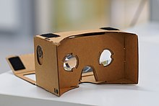

Figure 2 shows Google's Cardboard Headset. this can be used with apps such as Google Expeditions.

1. Domains

Google Expeditions is being used primarily for **educational purposes**. These included trips to natural landscapes; tours of cultural institutions such as museums; and explorations of historical, futuristic, and distant sights (such as dinosaurs or the moon). Students could look and move around freely. The program included Google Street View recordings and "AirPanos".

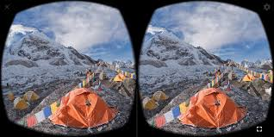

Figure 3 shows how it looks like from the Google's Headset with Expeditions app running.

1. Technology

The Google Expeditions app offered a variety of virtual excursions. These included trips to natural landscapes; tours of cultural institutions such as museums; and explorations of historical, futuristic, and distant sights (such as dinosaurs or the moon). Students could look and move around freely. The program included Google Street View recordings and "AirPanos" (panoramic captures taken from the air).

1. History

After Google Cardboard was announced in 2014, the product showed immediate promise within the education sector. Google Expeditions was presented for the first time at **Google I/O 2015**, with a launch date of September 2015. Since May 2016, over a million students have taken part in a virtual tour via the program. In July 2017, Google began a training initiative for the program based in Munich. Expedition trainers visit schools across Germany, bringing with them complete Expeditions kits. The nonprofit organization Stiftung Lesen supports the use of Google Expeditions in schools and libraries.

1. Types of Systems

Google Expeditions can only run on **mobile devices**. It cannot run on desktop machines or any other types of machines. Each student (preferably) needs a smartphone with a gyroscope and accelerometer; for Android version 4.4 or later, for iOS 8.0 or later; 1GB ram.

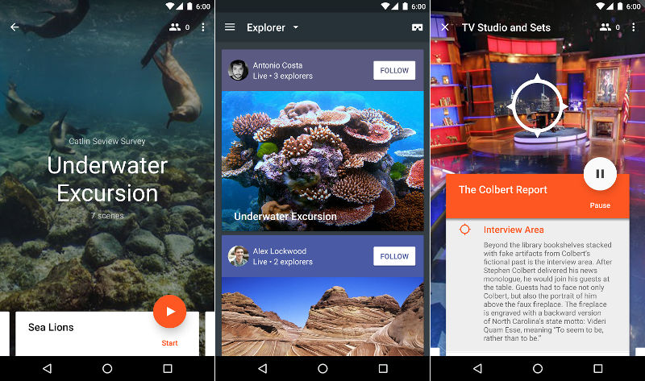

Figure 4 shows the Google Expeditions app running on mobile devices. This app is made only for mobile devices and cannot be used in desktop computers.

1. Connection & Configurations

Following are the connections and configurations needed for Google Expeditions:

1. Each student (preferably) needs a virtual reality Google Cardboard viewer.
2. Each student (preferably) needs a smartphone with a gyroscope and accelerometer.
3. Android version 4.4 or later, for iOS 8.0 or later is required.
4. 1GB of minimum memory (RAM) is required.
5. It must be noted that Google Expeditions run only on mobile devices.
6. Google Expeditions app installed on all devices, from Google Play (for Android) or from iTunes (for iOS).
7. Peer-to-peer (P2P) network established.
8. Benefits

Following are the main benefits of Google Expeditions:

1. The low cost of Google Cardboard is one of the main reasons why it is such a great option for educators.
2. Google Cardboard is one of the first VR headsets that was specifically designed to be readily accessible to the masses.
3. It is kid-friendly as expensive headsets are not a good choice for kids.
4. Google Cardboard is one of the simplest virtual reality headsets to set up and use.

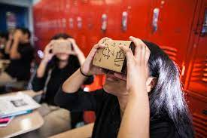

Figure 5 shows a classroom environment, with students interacting with Google's Headset and Expeditions application.

1. Drawbacks

Following are the major drawbacks of this app:

1. There is a lack of content.
2. The app is poorly supported, and is being discontinued. In other words, it is being merged into a more broader Google Arts & Culture.